Dandelions Pre-School Existing Injury Record
Date | Name |  | D.O.B
Time | Date and time of accident | Location
Type of injury
Advised by parent or notified by staff?
What action was taken? Give details of further medical treatment required or further observation
Was medical advice sought: Yes No (circle)
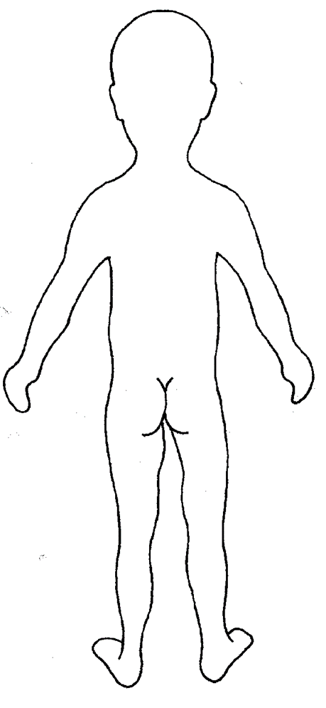
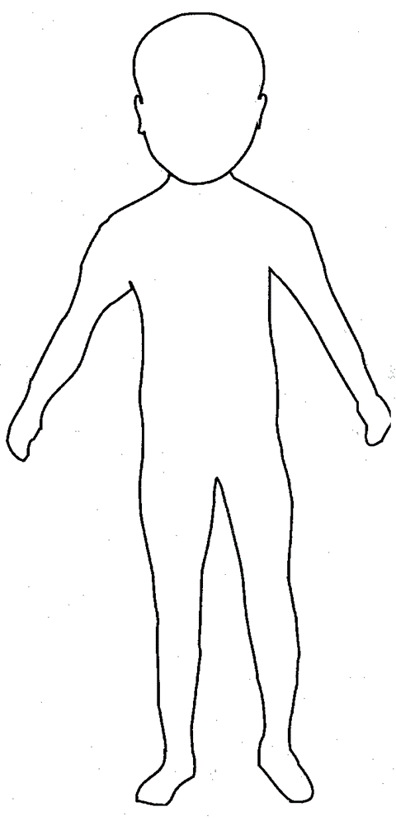
Body Map

Explain fully the events leading up to the accident and the accident itself.

Do we need to provide any additional support to your child whilst in pre-school?

Staff Signature | Witness Signature | Manager Signature | Parent/Carer Signature
Print Name | Print Name | Print Name | Print Name
Date | Date | Date | Date

