It is lovely to see the children all settled as they embark on their journey at Dandelions.
They have been very inquisitive about the changes in the environment and have been exploring using their senses.
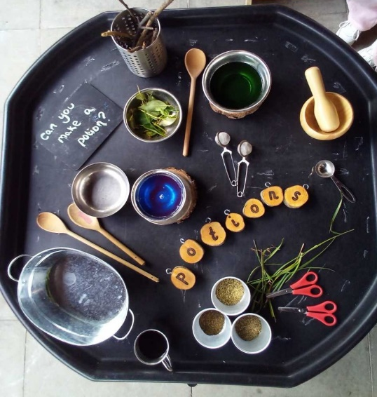
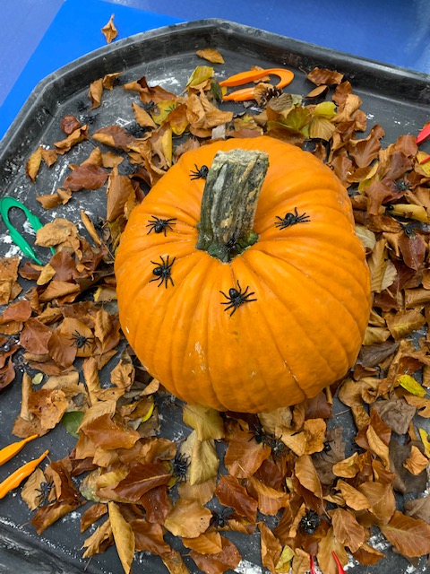
To inspire curiosity the staff have provided a range of learning provocations to promote childrens engagement Our provocations are open-ended and focus on the childrens interest.
From making magic potions with water and food coloring with a hint of spice! To getting slimy with the Dinosaurs!

We have been practicing fine motor skills by finding toy bugs with tweezers in our natural resources and mark making.
This week we are celebrating Halloween and have been carving a pumpkin to find out what is inside. We are also celebrating Diwali by creating decorations and sampling some tasty treats.
With ours sponsored Treasure hunt coming up in half term we are looking forward to continuing our focus on Autumn when we return. From the autumnal treasures collected we will be creating our very own Dandelions autumn collage.
Spaces are filling up fast and we are building our waiting lists for the next two years so please do contact us for a registration form if you would like to consider us for your child’s early years on
01256 818857 or alternatively e-mail info@dandelions-preschool.org.uk

