Newsletter December 2023
Wow, first term nearly complete. We are not to sure where the time has gone.
What an amazing term it has been. For Dandelions, there has been lots of ‘firsts’. Our trip to the little farm at St Mark’s School which was a great success and we are hoping to be able to visit again very soon.
Lizzie from Boogie Mites joined us in November and ran a 4 week session on a Wednesday to help support the children with there listening and attention skills. The engagement from the children has been amazing. So much so, we have invited Lizzie back next year. In January, Lizzie will join us on a Thursday morning.
We have built such a lovely relationship with the staff and residents at Dashwood Manor Care Home, from making the Gruffalo scarecrow, decorating poppies, visiting the care home to sing our Christmas songs and finally for them providing us with our special visitor in the grotto. A big thank you to the Dandelions Committee for creating such an amazing grotto.
We cannot wait to see what 2024 brings.

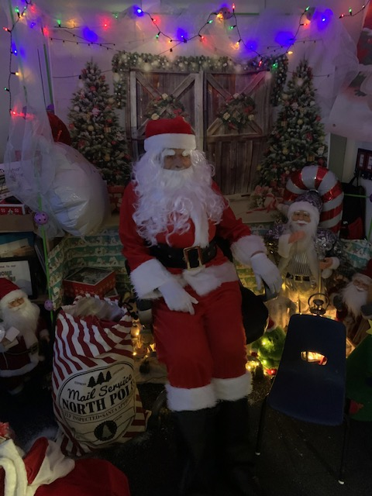
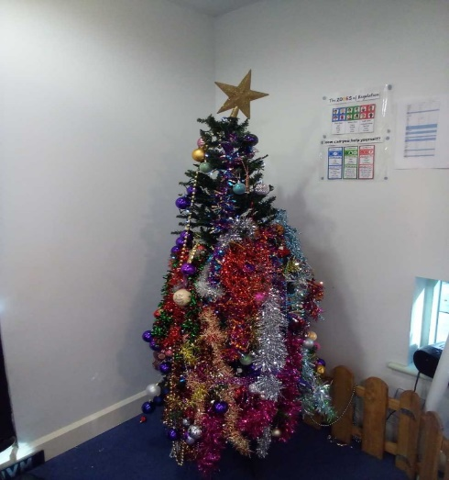
Thank you to everyone who came along for our Craft mornings. It was lovely to see so many parents. We hope you enjoyed it as much as we did.

Our Christmas Raffle raised £181.00
All fundraising money goes back in to the pre-school. Next year, we are hoping to purchase a reading den for outside.

Committee
Thank you to those of you who joined us for our AGM meeting last month. It is not too late if you would like to find out information about joining the committee.
Our new committee is:
Natasha Southwell – Chair Zoe Southcott – Treasure Joellie Gregory – Secretary

Committee members: Simone Nel, Raegan Baylie, Natalie Cassell and Cara Mills.

Finally we would like to send our thanks for all of your generous gifts to the staff. They are very much appreciated.

We Wish you all a very Merry Christmas and a Healthy and Happy New Year. We look forward to seeing you all in January.

A few reminders for when we return

If your child is showing any symptoms such as temperature, upset tummy or generally feeling unwell and you feel that they may need calpol or other medication please do not send them into preschool. If your child requires any form of medication at home can you please ensure you update us even if this is a short course of antibiotics.

Please don’t forget to inform us if anyone else is going to be picking your child up from pre-school. We will require a password.

Parent Parking: unless you have permission from St Mark’s, please can we ask that you do not park in the school car park.

Please remember to label children’s coats, jumpers, wellies, lunch bags, drink bottles etc.

Check your child’s artwork tray regularly.

TAPESTRY – we love to see your updates from home. Please keep them coming over the Christmas holidays. The children also enjoy looking at the pictures with us when they are in the setting.

Reminder for parents needing ‘30 hours childcare’ from January 2024
All parents who are working, have a 3-or 4-year old and want to claim funded extended hours (30 hours childcare), must make sure they have applied to HMRC before the 31 December 2023. All parents with a 30 hours code need to make sure their details are up to date. They must do this every three months: https://www.gov.uk/sign-in-childcare-account
Help paying for childcare: Childcare Choices | 30 Hours Free Childcare, Tax-Free Childcare and More | Help with Costs | GOV.UK

First Day of Term
We are back open on Wednesday 3rd January 2024
School Applications – REMINDER
If your child is due to start Reception in 2024, the deadline date for school applications is 15th January 2024

